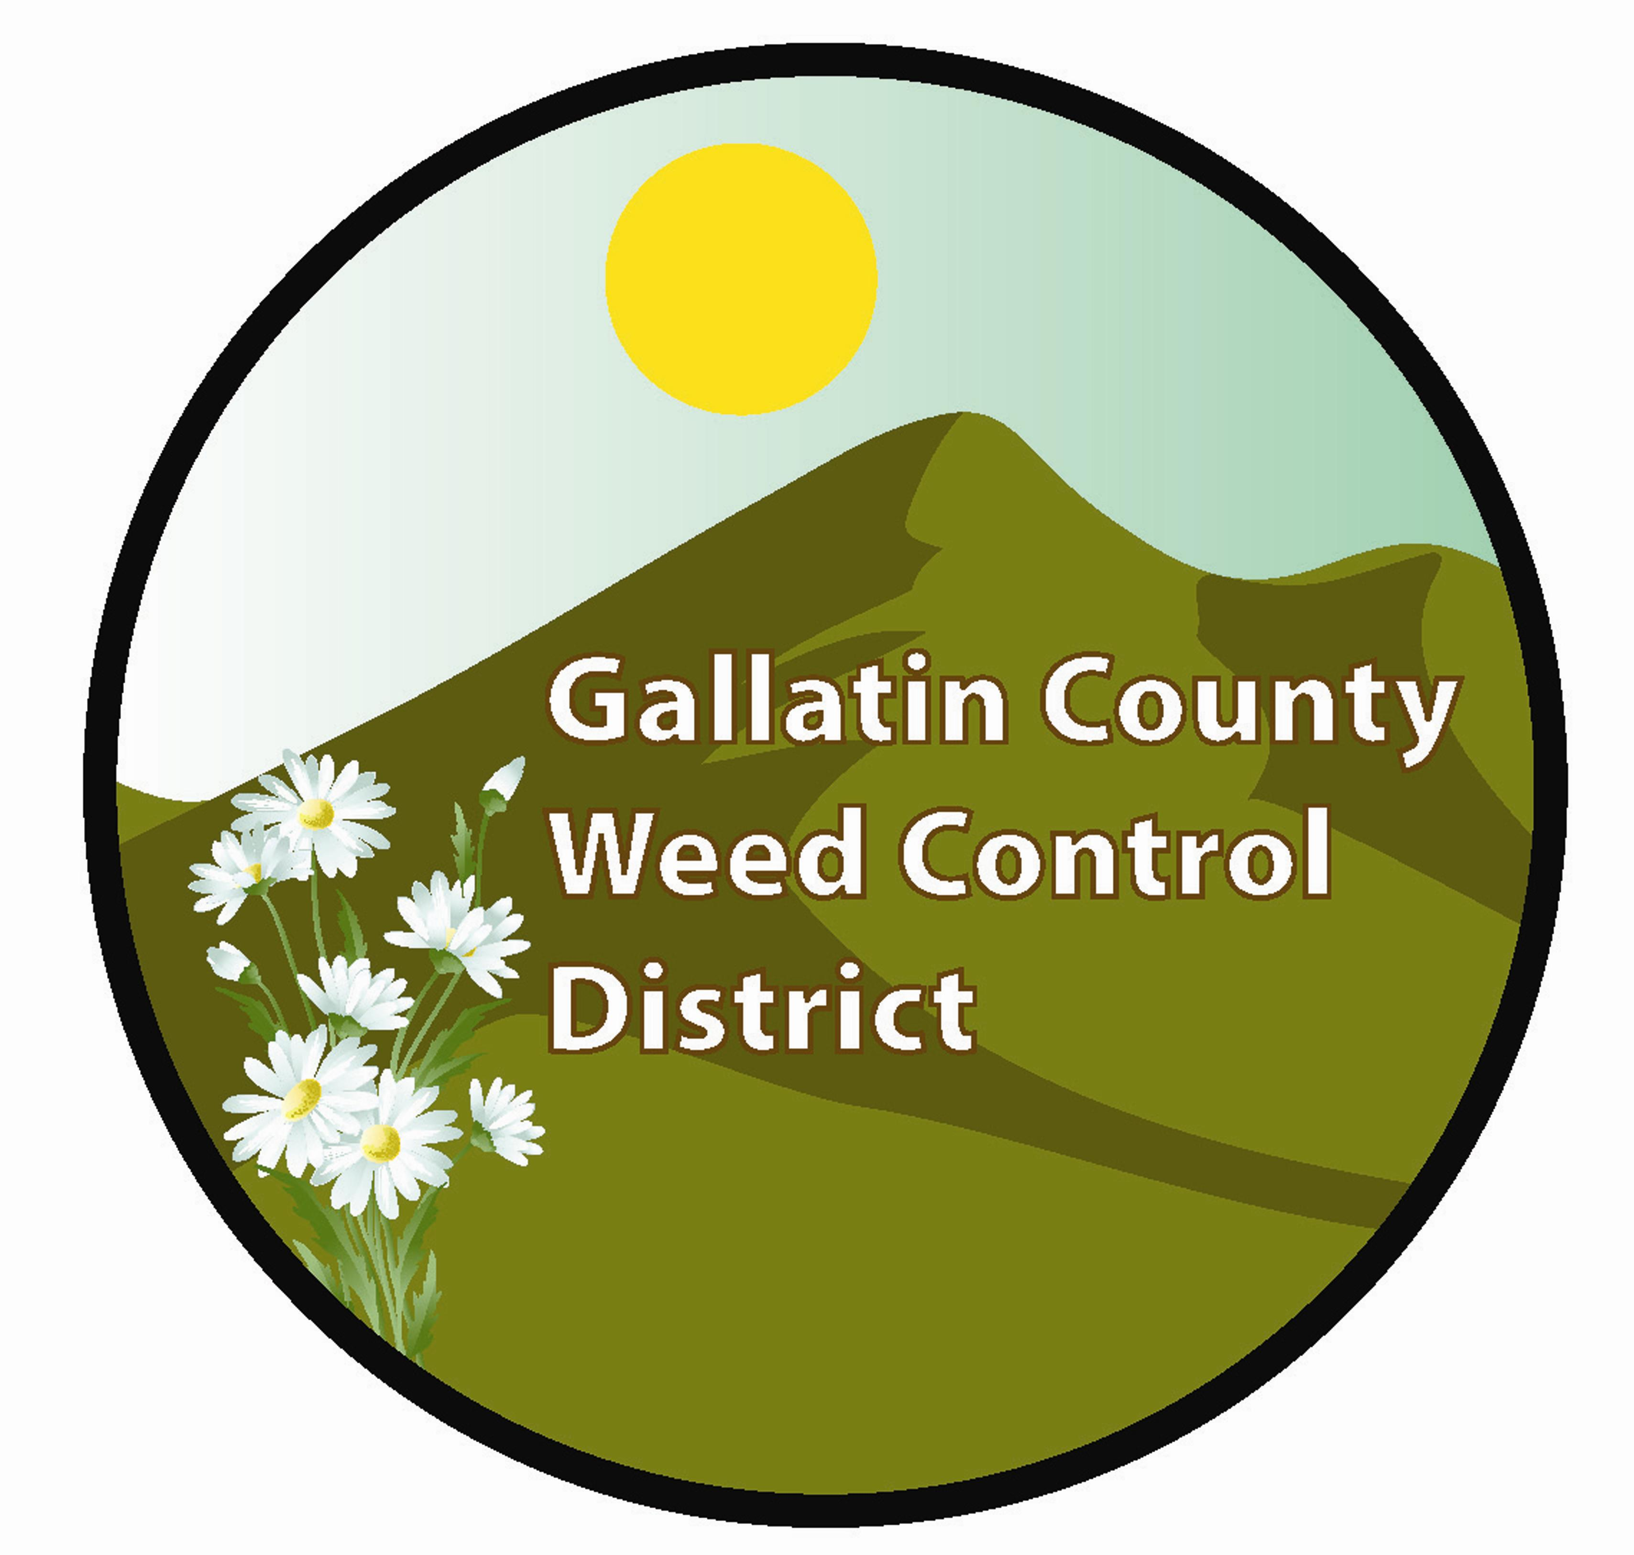GALLATIN COUNTY WEED DISTRICT

901 North Black

Bozeman, MT 59715

REGULAR MONTHLY MEETING

November 03, 2011
1.15PM in the Ag Center Meeting Room

AGENDA

 | Minutes
 | OLD BUSINESS
1. | Road Department Encroachment Permit
2. | Preliminary Plat Extensions for Subdivisions
3. | New Weed Law
 | NEW BUSINESS
1. | Public Comment
2. | Monthly Report Q&A
3. | Grants Update
4. | Commissioner Report
5. | Coordinator(s) Report  - Fall Coordinator Training  - Spray projects – county roads and Fairgrounds  - Equipment Winterization/Maintenance  - Spray Truck
6. | Round Table/Other

The Board reserves the right to deviate from the order of the topics listed on this agenda. A person desiring to hear a particular topic should plan to be present at the start of the meeting.
If you have a special need or disability, or would like additional information about agenda items, please contact the Weed District Office at (406) 582-3265 or email weeddistrict@gallatin.mt.gov

